TRƯỜNG ĐẠI HỌC SÀI GÒN

KHOA CÔNG NGHỆ THÔNG TIN

BÀI BÁO CÁO BÀI TẬP LẦN 2 HỌC KỲ I
NĂM HỌC 2025-2026
Học phần: KIỂM THỬ PHẦN MỀM
Phân tích thiết kế hệ thống

GVHD TS. Đỗ Như Tài
Nhóm 7 Nguyễn Phương Vinh 3122411247
Lê Ngọc Hiệp 3122411053
Trần Hảo Điền 3122411042
Ngô Tuấn Anh 3122411007

Thành phố Hồ Chí Minh, Tháng 09/2025

Lời cam đoan
Tôi xin cam đoan đây là công trình báo cáo của cá nhân tôi và nhóm. Các nội dung nghiên cứu trong báo cáo đề tài (Phân tích thiết kế hệ thống) của nhóm tôi là trung thực. Nếu có phát hiện bất kỳ sự gian lận nào thì tôi xin hoàn toàn chịu trách nhiệm về bài báo cáo của tôi.

MỤC LỤC
TRƯỜNG ĐẠI HỌC SÀI GÒN 1
I. BUSINESS CONTEXT 4
a) Business context 4
II. CONCEPTUAL MODEL 5
a) Conceptual model 5
III. USE CASES 6
a) Product Catalog 6
b) Shopping Cart 7
c) Order Management 8
d) Inventory 9
e) Access Control 10
IV. USER STORY 10
a) Product 10
b) Shopping Cart 11
c) Order Management 12
d) Inventory 12
d) Access Control 12

Thành viên | Email | Mã SV
Trần Hảo Điền | haodientran04@gmail.com | 3122411042
Ngô Tuấn Anh | anhngo876@gmail.com | 3122411007
Nguyễn Phương Vinh | nguyenphuongvinh49@gmail.com | 3122411247
Lê Ngọc Hiệp | supermanlnh@gmail.com | 3122411052

I. BUSINESS CONTEXT

a) Business context
Grocery App covers the entire grocery shopping journey – from product discovery, cart management, order placement and tracking, to the seller’s dashboard – through well-defined frontend/backend routes.
- Product Catalog: Buyers can browse the full catalog, search by name, filter by category, and view detailed information for each item (description, original/discounted price, image gallery) directly on the listing or product detail page. Administrators can log into the seller area to upload images, enter new product information, and toggle “in stock” status via secured APIs with file upload support.
- Shopping Cart & Checkout: Buyers can add items from product cards or detail pages, adjust quantities, view the total – including free shipping and a 2% tax – choose delivery addresses and payment methods (default COD) before placing an order. All changes are instantly synchronized with the server. Cart data is stored alongside the user profile in MongoDB via an authenticated endpoint with cookies, preserving state across logins.
- Order Management: The system calculates the total (including tax), records the item list, address, and payment type when a buyer confirms a COD order, and then provides APIs for customers to view their order history and for sellers to monitor all paid or COD orders.
- Address Book: Buyers can create new delivery addresses with all required fields, save them in the database, and reuse them during checkout. The cart interface allows quick switching between saved addresses or adding a new one.
- Seller Operations & Inventory: The /seller route is restricted by dedicated login. Once authenticated, admins access a dashboard to manage products (add new items, update stock) and review all orders along with customer delivery information.
- Access Control & Authentication: Buyers register/login through a modal, receive JWTs stored in HttpOnly cookies, and all sensitive APIs validate the token. Sellers log in with preconfigured credentials, and their tokens are also verified by middleware before accessing administrative resources.
- Initialization Tasks: Include configuring environment variables for MongoDB connection, JWT secret, seller login credentials, and Cloudinary account for image storage; ensuring the upload folder is ready; and importing initial product data (via the seller dashboard) before opening the store to customers.

II. CONCEPTUAL MODEL

a) Conceptual model
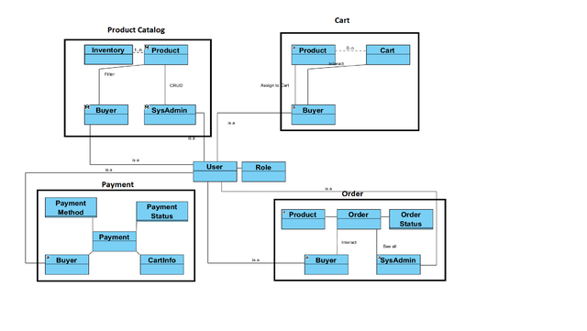

III. USE CASES

a) Product Catalog
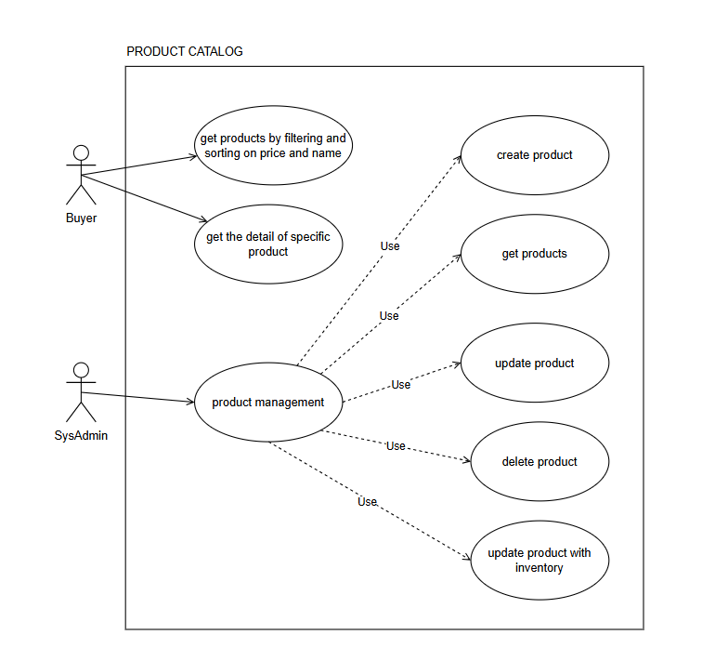

b) Shopping Cart
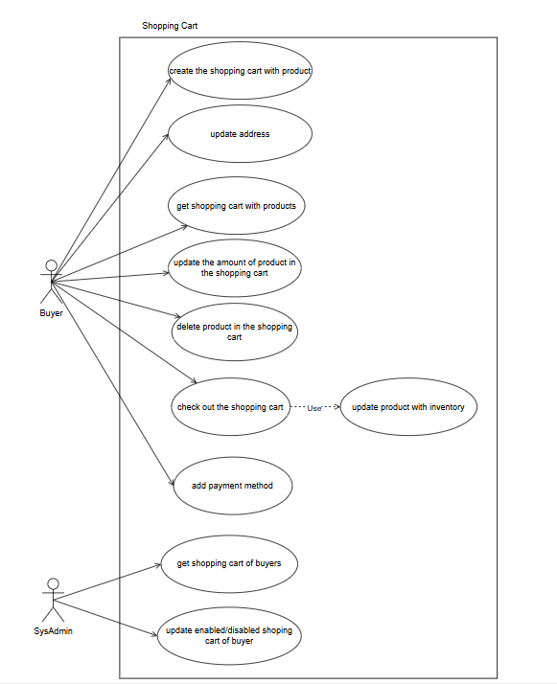

c) Order Management
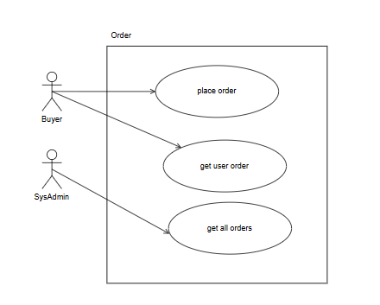

d) Inventory
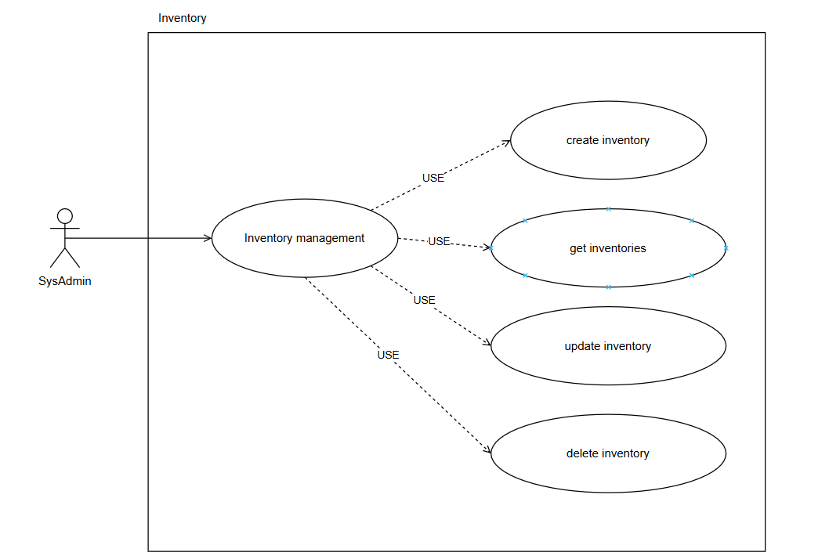

e) Access Control
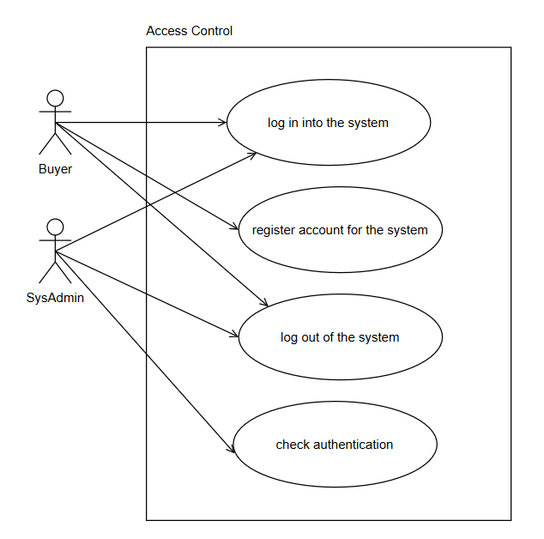

IV. USER STORY

a) Product
• As a Buyer, I want to see the list of products with filtering, sorting on the
home page (name, photo, short description, rating, and hot product flag which is a product with a lot of people seeing or buying).
• Whenever filtering with any price and name of the product, then the list of products need to narrow down with appropriate products.
• As a Buyer, I want to navigate into the detail of one product with the basic
attributes such as name, description, available product in the inventory, the
inventory store information like stock address and location, a hot product
flag (if has) and rating
• As a SysAdmin, I want to manage a product (CRUD actions) and assign one
existing inventory into the product.

b) Shopping Cart
• As a Buyer, I want to buy any product on the product catalog page (add this product into the shopping cart - one product will be added by default).
• As a Buyer, I want to see the product details and buy this product if I like (add this product into the shopping cart - one product will be added by default).
• As a Buyer, I want to see the list of products I just added into the shopping cart, and I would like to see the summary information panel for the current shopping cart such as cart total cost, promotion item saving cost, subtotal cost, shipping cost, promotion shipping savings cost, total order amount on this page.
• As a Buyer, I want to update the amount of product in the shopping cart.
• Whenever an update of products happens, then the summary information panel needs to be updated accordingly to changes.
• As a Buyer, I want to delete any product in the shopping cart which they don't want to buy anymore.
• Whenever the deleting amount of product happens, then the summary information panel needs to be updated accordingly to changes.
• As a Buyer, I want to check out my shopping cart.
• Whenever the number of products in the shopping cart is zero then this checks out process does not happen.
• While a shopping cart was checked out, the payment process start.
• As a SysAdmin, I want to see the shopping cart of all buyers with information about cart total cost, promotion item saving cost, subtotal cost, shipping cost, promotion shipping savings cost, total order amount.

c) Order Management
• As a Buyer/SysAdmin, I want to order the products in the shopping cart, pay in cash or online payment.
• As a SysADmin, I want to manage users' orders.

d) Inventory
• As a SysADmin, I want to manage inventory (CRUD actions)

d) Access Control
• Each Buyer/SysAdmin is a User.
• As a Buyer/SysAdmin, I want to log-in to the system.
• Whenever a user with a Buyer role does a login, then I will be brought to the product catalog page/home page.
• Whenever a user with a SysAdmin role does a login, then I will be brought to the administration page.
• As a Buyer/SysAdmin, I want to log-out of the system.

